# Gym Management System Application

Create a gym management system including members, fee packages and bills.

# Database design

This app can revolve around this simple design:

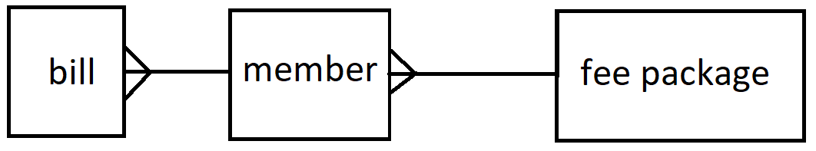

# fee package

This is a type of membership that can be selected by a member. A few of these should be prepopulated. Having a form that creates / edits / deletes fee packages can also be incorporated.

# member

A member is a customer. The app user can create / edit / delete members and associate each member with a fee package.

# bill

A bill is per member, per month unless they have frozen their subscription (optional). Bill records get created every month initially in ‘owed’ status and then they are ‘paid’.

# Additional things to think about

Error handling

Testing

Documentation (User guide / walkthrough && readme)